**School of Information Technology and Engineering[SITE]**

November, 2022.

**ONLINE CAKE WEBSITE**

**A cal J-COMPONENT PROJECT Report**

**For Web Development(ITA1007)**

**of**

**Bachelor of Computer Application**

***In***

**Computer Application**

*By*

**Vinay Krishnan (21BCA0159)**

**Harshitha .V (21BCA0176)**

**Tejashree . S (21BCA0192)**

|  |  |  |
| --- | --- | --- |
| **CHAPTER NO.** | **TITLE** | **PAGE NO.** |
|  | **ABSTRACT** | 2 |
|  | **LIST OF TABLES** |  |
|  | **LIST OF FIGURES** |  |
|  | **LIST OF SYMBOLS** |  |
| 1. | **INTRODUCTION** | 4 |
|  | 1.1 Motivation | 4 |
|  | 1.2 Issues |  |
| 2. | **PROBLEM DEFINITION** |  |
|  | 2.1 Critical Issues |  |
|  | 2.2 Problem Definition |  |
| 3 | **PROJECT DESCRIPTION** | 5 |
|  | 3.1 List of Modules |  |
|  | 3.2 Requirements Specification |  |
|  | 3.2.1 Software Requirements |  |
|  | 3.2.2 Hardware Requirements |  |
|  | 3.3 Module Description |  |
| 4 | **IMPLEMENTATION OF PROJECT** | 6 |
|  | 4.1. Source code | 7 |
|  | 4.2 Snapshot/Screen shots of the project | 14 |
| 5 | **RESULTS AND DISCUSSION** |  |
| 6 | **CONCLUSION AND FUTURE WORK** | 20 |
|  | **References** |  |

**ABSTRACT**

The topic for the project is Online Cake Website. We have added several functionalities to the project like shopping cart, Payment Portal and Login/Registration form. The website consists of a home page and several other webpages for different purposes like Registration, Payment, Contact information and ‘About’ of the website. Our project is based on creating an online website using web-development based programming languages and frameworks, In short the idea is to make online cake shop which will provide our customers to view and choose custom cakes and buy readily available delicious cakes. We have used HTML, CSS, Javascript for front end designing and development.

**INTRODUCTION**

Our website is developed in such a way that allows users to check for various cakes available at the online store and purchase online. The project consists of list of Cakes and bakery products displayed in various categories. The user may browse through these items as per categories. If the user likes a product user may add it to his shopping cart. User can pay using their credit/debit cards and have their product ordered.

Online Cake shopping project brings an entire cake shop online and makes it easy for both buyer and seller. The user interface is simple and easy to understand. Our website will also have pictures of already ready-to-serve cakes. Our website’s front-end is designed using Html, Css, Javascript. The users can also login/register in the website so that they can access their previous cart items as well when they buy cakes the next time.

To shop from our website the user or customer must be registered by clicking on register/signup which will create his shopping account. While registering customers are expected to enter all his true details like his real full name, age, addresses, card details(not mandatory), phone number and email address.

When customer clicks on login/sign up link user will be redirected to login page & register option will also be available then when user will login (only if user has registered) , the cake user selected will get added to his cart and thereafter if user want user can add more food to his cart and thereafter user can checkout by option available when user enters cart page so after clicking checkout the user will be redirected to his bank’s payment gateway.

**ARCHITECTURE DIAGRAM**

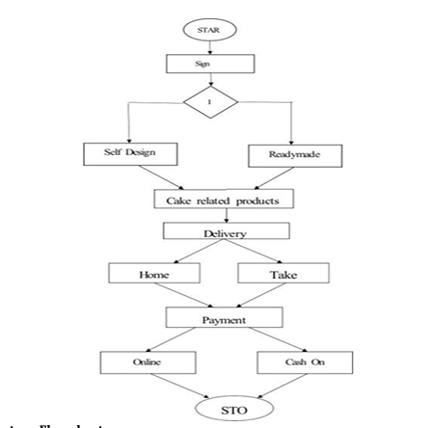

**DATA BASE DESIGN**

**Sample CODE**

**HOME PAGE (Sample):**

 <div id="maindiv">

        <div id="headerdiv">

            <div id="imagelink">

                <a href="Jcomp.html">

                    <img src="cake shop logo-edited2.jpg" width="150" height="100"></td>

                </a>

            </div>

            <div class="container-name">

                <a class="example_f" href="Profile_page.html" target="_blank" rel="nofollow">

                    <span id="50">Profile</span>

                </a>

            </div>

            <div>

                <input class="search" type="text" placeholder="Search">

            </div>

            <div id="linklogin">

                <div class="open-button" onclick="openForm()">

                    <div class="link">Login/Sign Up</div>

                </div>

            </div>

            <div id="cartlink">

                <a href="#1" class="link">My Cart</a>

            </div>

            <a href="about us.html">

                <div class="link" id="aboutuslink">

                    About Us

                </div>

            </a>

            <div id="contactlink">

                <a class="link" href="contact.html">Contact</a>

            </div>

            <div class="reviewpage">

                <a class="link" href="Reviewpage.html">Reviews</a>

            </div>

        </div>

        <div class="form-popup" id="myForm">

            <form action="/action_page.php" class="form-container">

                <h1>HELLO!! CAKE LOVERS</h1>

                Please enter your e-mail ID and Password<br><br>

                <label for="email"><b>Email:</b></label><br><br>

                <input type="text" placeholder="Enter Email" name="email" required><br><br>

                <label for="psw"><b>Password:</b></label><br><br>

                <input type="password" placeholder="Enter Password" name="psw" required><br><br>

                <button type="submit" class="btn">

                    <div class="buttonhover">Login</div>

                </button>

                &emsp;

                <button type="button" class="btn register">

                    <div><a class="buttonhover" href="Register.html" target="_blank">Register</a></div>

                </button>

                &emsp;

                <button type="button" class="btn cancel" onclick="closeForm()">

                    <div class="buttonhover">Close</div>

                </button>

            </form>

            <div>

                <img id="img_inside_popup" src="cake_img_for_popup.jpg">

            </div>

        </div>

        <div id="slider">

            <ul id="slideWrap">

                <li><img src="slider.jpeg" alt=""></li>

                <li><a href="#5"><img src="slider2.jpeg" alt=""></a></li>

                <li><img src="slider1.jpeg" alt=""></li>

                <li><a href="#6"><img src="slider3.jpeg" alt=""></a></li>

                <li><a href="#4"><img src="slider4.jpeg" alt=""></a></li>

            </ul>

            <a id="prev" href="#">&#8810;</a>

            <a id="next" href="#">&#8811;</a>

        </div>

**JAVASCRIPT CODE FOR MOVING CAROUSAL IMAGES:**

 var responsiveSlider = function () {

            var slider = document.getElementById("slider");

            var sliderWidth = slider.offsetWidth;

            var slideList = document.getElementById("slideWrap");

            var count = 1;

            var items = slideList.querySelectorAll("li").length;

            var prev = document.getElementById("prev");

            var next = document.getElementById("next");

            window.addEventListener('resize', function () {

                sliderWidth = slider.offsetWidth;

            });

            var prevSlide = function () {

                if (count > 1) {

                    count = count - 2;

                    slideList.style.left = "-" + count * sliderWidth + "px";

                    count++;

                }

                else if (count = 1) {

                    count = items - 1;

                    slideList.style.left = "-" + count * sliderWidth + "px";

                    count++;

                }

            };

            var nextSlide = function () {

                if (count < items) {

                    slideList.style.left = "-" + count * sliderWidth + "px";

                    count++;

                }

                else if (count = items) {

                    slideList.style.left = "0px";

                    count = 1;

                }

            };

            next.addEventListener("click", function () {

                nextSlide();

            });

            prev.addEventListener("click", function () {

                prevSlide();

            });

            setInterval(function () {

                nextSlide()

            }, 5000);

        };

        window.onload = function () {

            responsiveSlider();

        }

**FORM VALIDATION IN REGISTRATION FORM (JS CODE):**

<script type="text/javascript">

        function formvalidation() {

            var uname1 = document.getElementById("uname");

            var userid = document.getElementById("uid");

            var uemail = document.getElementById("email");

            var passid = document.getElementById("passid");

            var uzip = document.getElementById("phno");

            var ugender = document.getElementsByName("gender");

            var uadd = document.getElementById("address");

            if (user_name(uname1, 5, 30)) {

                if (user_id(userid, 8, 12)) {

                    if (validgender(ugender)) {

                        if (alphanumeric(uadd)) {

                            if (programme(progr)) {

                                if (ValidateEmail(uemail)) {

                                    if (allnumeric(uzip)) {

                                        if (passid_validation(passid, 7, 12)) {

                                        }

                                    }

                                }

                            }

                        }

                    }

                }

            }

            return false;

        }

        function user_name(uname1, my, mx) {

            var letters = /^[A-Za-z]+$/;

            var uname1_len = uname1.value.length;

            if (uname1.value.match(letters) && uname1_len >= my && uname1_len <= mx) {

                return true;

            }

            else {

                alert('Username must have alphabet characters only and it should be between ' + my + ' to ' + mx);

                uname1.focus();

                return false;

            }

        }

        function passid_validation(passid, mx, my) {

            var passid_len = passid.value.length;

            if (passid_len == 0 || passid_len >= my || passid_len < mx) {

                alert("Password should not be empty / length be between " + mx + " to " + my);

                passid.focus();

                return false;

            }

            return true;

        }

        function user_id(userid, my, mx) {

            var letters = /^[A-Za-z]+$/;

            var userid_len = userid.value.length;

            if (userid.value.match(letters) && userid_len >= my && userid_len <= mx) {

                return true;

            }

            else {

                alert('Userid must have alphabet characters only and it should be between ' + my + ' to ' + mx);

                uname1.focus();

                return false;

            }

        }

        function validgender(ugender) {

            var isChecked = false;

            for (var i = 0; i < ugender.length; i++) {

                if (ugender[i].checked) {

                    isChecked = true; // found one element checked

                    break;

                }

            }

            if (isChecked == false) {

                alert("Select male/female");

            }

            return isChecked;

        }

        function reg_no(regno) {

            var letters = /^[a-zA-Z0-9]+$/;

            if (regno.value.match(letters)) {

                return true;

            }

            else {

                alert("Registration no should contain alphanumeric value only");

                regno.focus();

                return false;

            }

        }

        function email_id(email) {

            var mailformat = /^\w+([\.-]?\w+)@\w+([\.-]?\w+)(\.\w{2,3})+$/;

            if (email.value.match(mailformat)) {

                return true;

            }

            alert("You have entered an invalid email address!");

            email.focus();

            return false;

        }

        function allnumeric(uzip) {

            var numbers = /^[0-9]+$/;

            alert("Test");

            if (uzip.value.match(numbers)) {

                alert("Test 2");

                return true;

            }

            else {

                alert('ZIP code must have numeric characters only');

                uzip.focus();

                return false;

            }

        }

        function alphanumeric(uadd) {

            var letters = /^[0-9a-zA-Z]+$/;

            if (uadd.value.match(letters)) {

                return true;

            }

            else {

                alert('User address must have alphanumeric characters only');

                uadd.focus();

                return false;

            }

        }

        function ValidateEmail(uemail) {

            var mailformat = /^([a-zA-Z0-9_\.\-])+\@(([a-zA-Z0-9\-])+\.)+([a-zA-Z0-9]{2,4})+$/;

            if (uemail.value.match(mailformat)) {

                return true;

            }

            else {

                alert("You have entered an invalid email address!");

                uemail.focus();

                return false;

            }}

**SCREEN SHOTS**

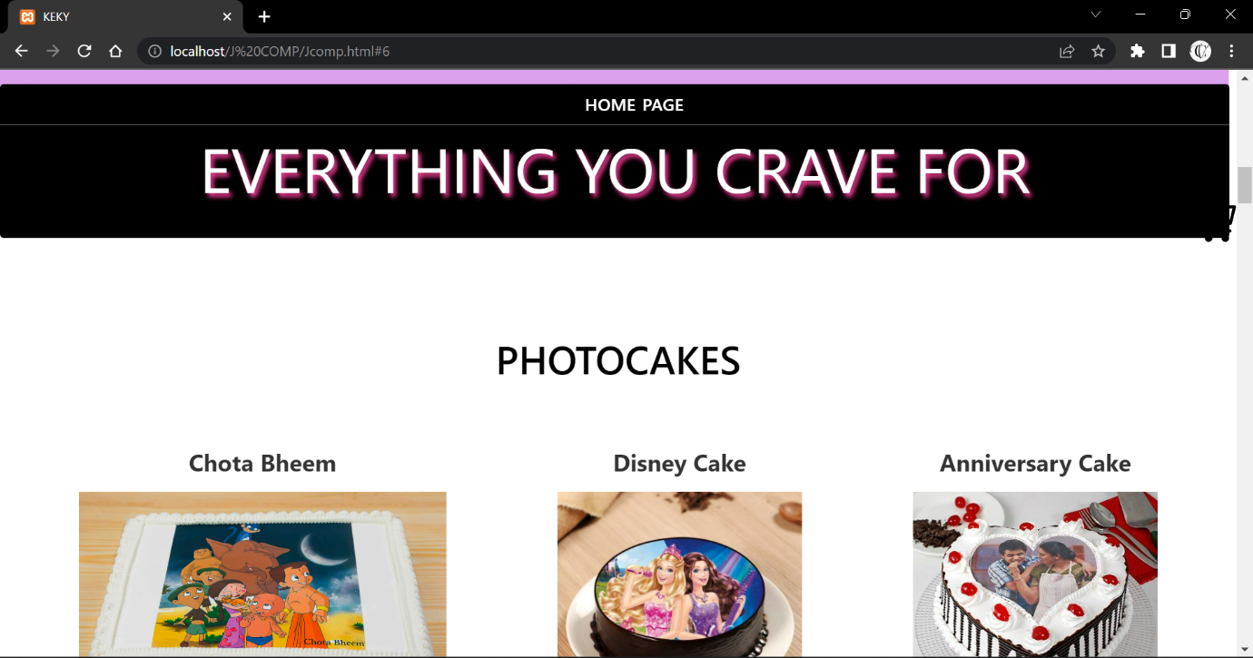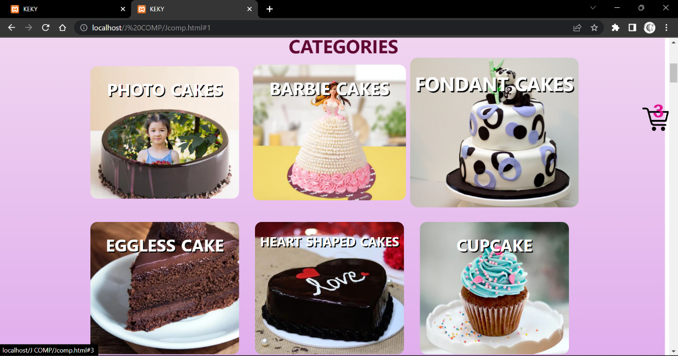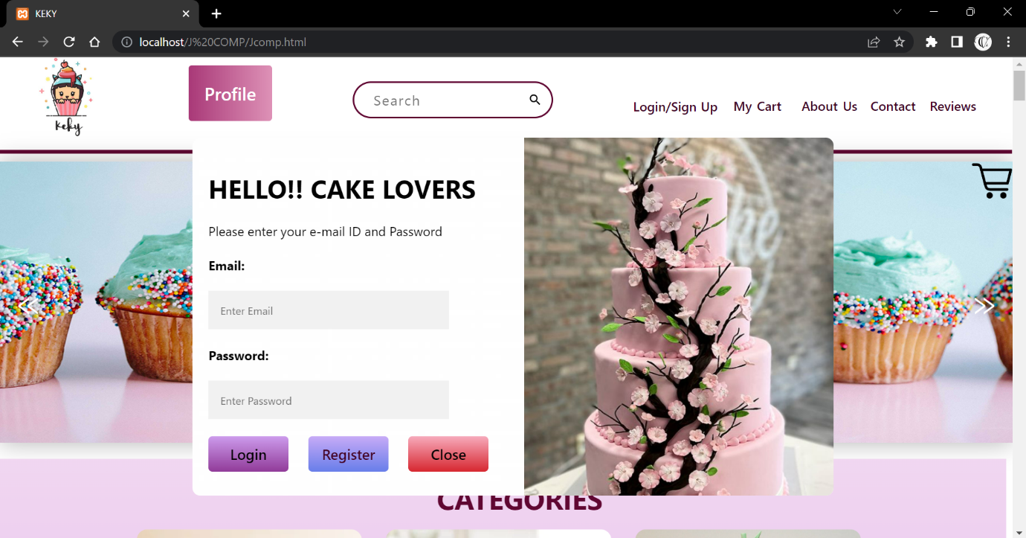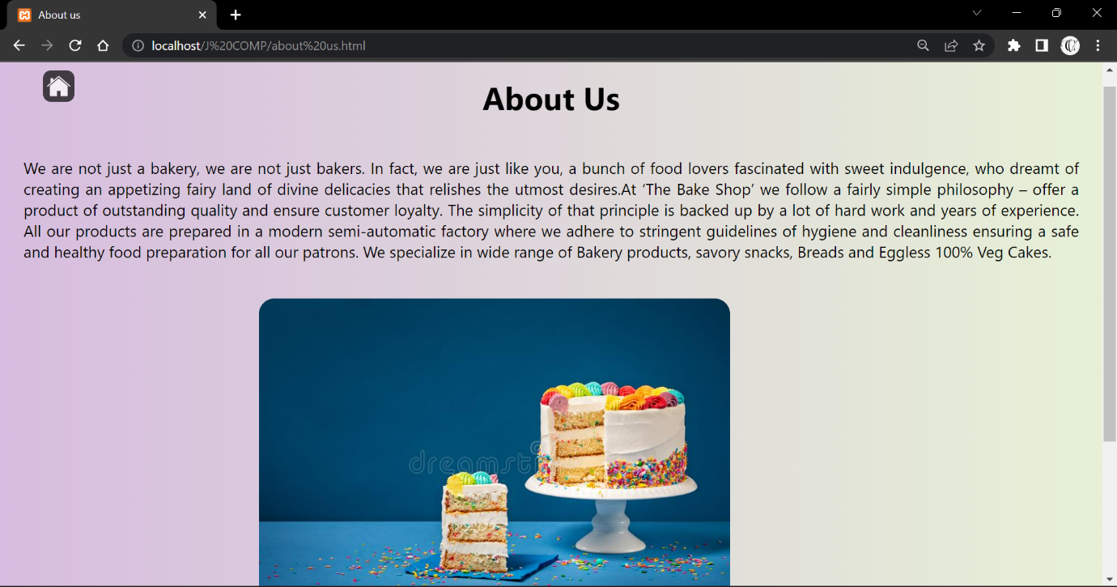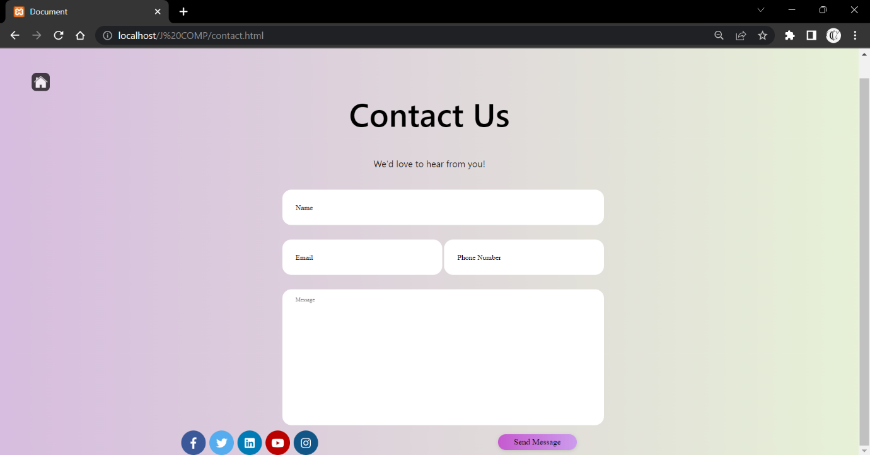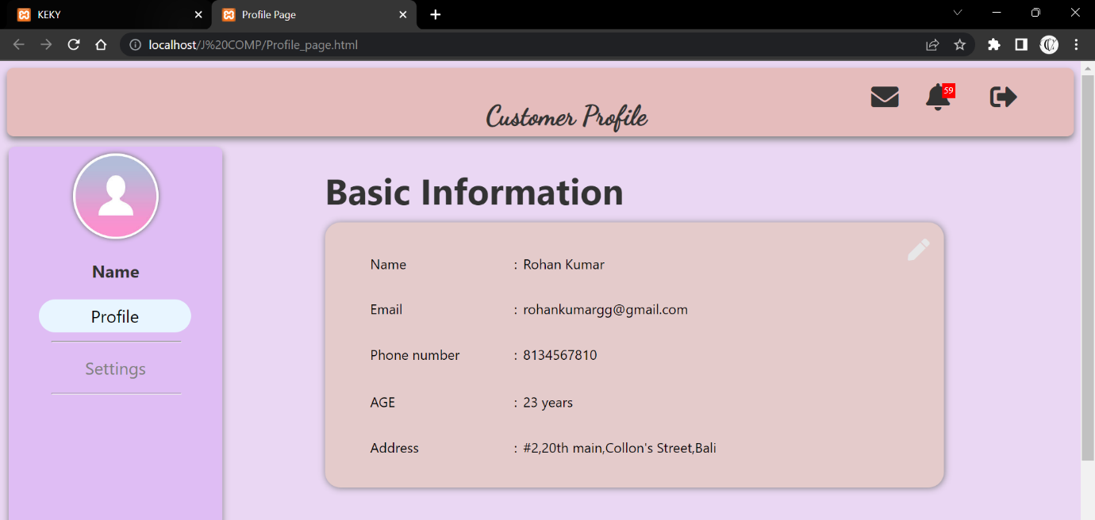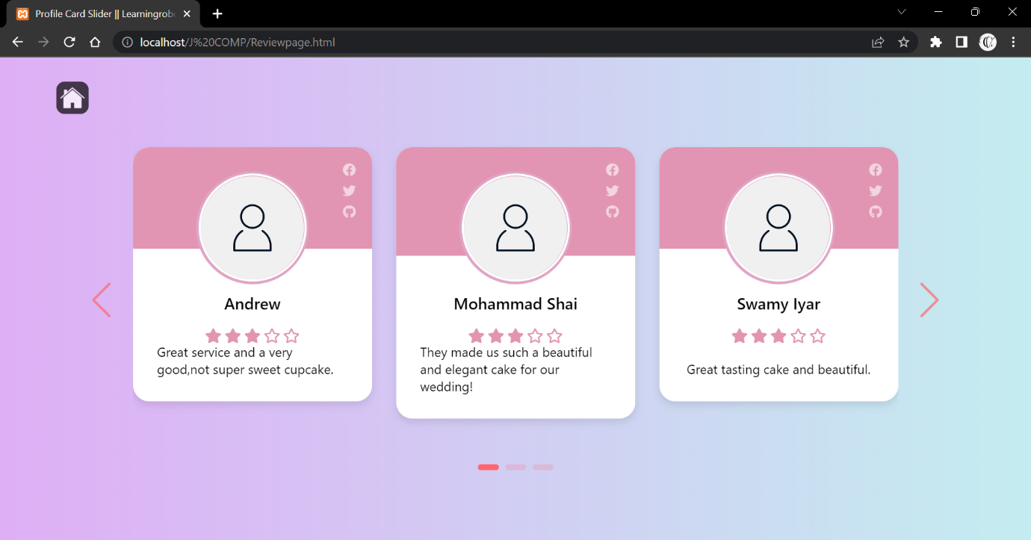

**CONCLUSION**

Online website for ordering cake and other bakery products is a simple way just from comfort of home. We have best present example of covid19, as most of the shops are closed & most of the people find bit risky to visit shops, Online shopping is convenient, easy, time saving, safe from customer’s point-of-view and from delivery executive’s point of view by providing no-contact-delivery. Our idea will boost cake & bakery businesses with low capital & more profits